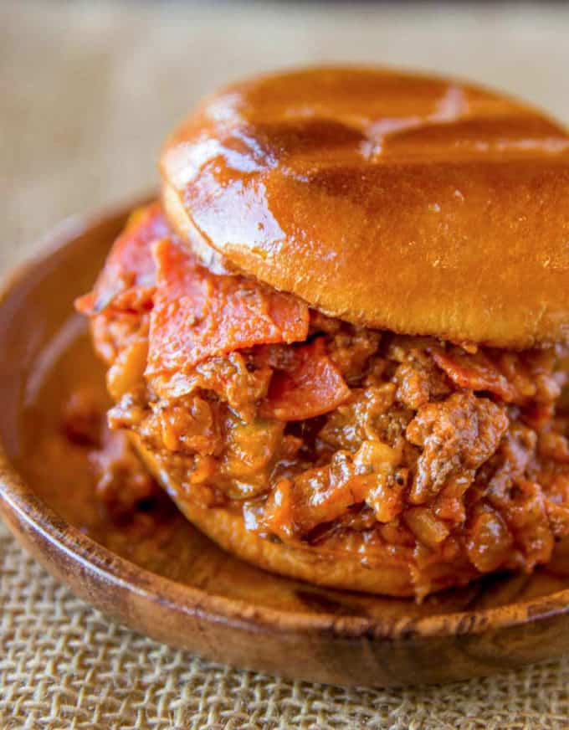
Pizza Sloppy Joes
Prep time 5 min Cook time 15 min
8 Sandwiches
Ingredients
1 lb lean Italian sausage
6 slices bacon
2 tbsp butter
1 small yellow onion diced
1 red bell pepper diced
¼ tsp Kosher salt
½ tsp fresh ground black pepper
1 cup marinara sauce
1 tbsp cornstarch
½ cup beef broth
6 oz shredded mozzarella cheese
Directions
- Cook the sausage in a large frying pan until meat is fully cooked. Remove and drain the fat.
- Cook the bacon in the pan until crispy. Remove the bacon and let cool before crumbling.
- Add the butter, onions and bell pepper to the pan with the remaining bacon grease.
- Let brown for 1 to 2 minutes before stirring, then let brown for another 1 to 2 minutes before stirring again.
- Add the sausage and bacon back into the pan.
- In a small cup mix the salt, black pepper, marinara sauce, beef broth and cornstarch together and add it to the pan.
- Cook until the mixture is only slightly liquidy (about 75% of the mixture is above liquid), 3 to 5 minutes.
- Spoon the mixture onto toasted buns and top with shredded mozzarella cheese.

